PCS223 Advanced Computer Networks
ASSIGNMENT -2

- To capture and analyze ICMP packets (Ping request and reply)

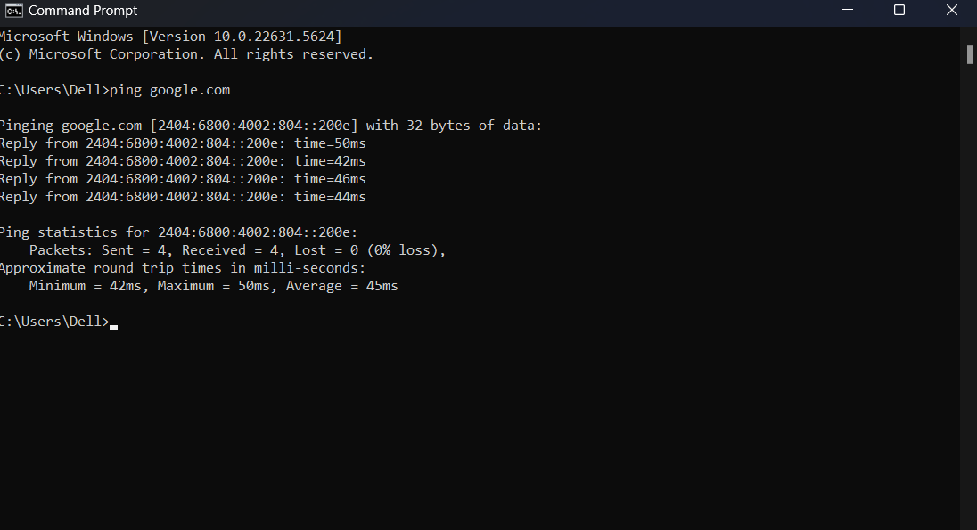

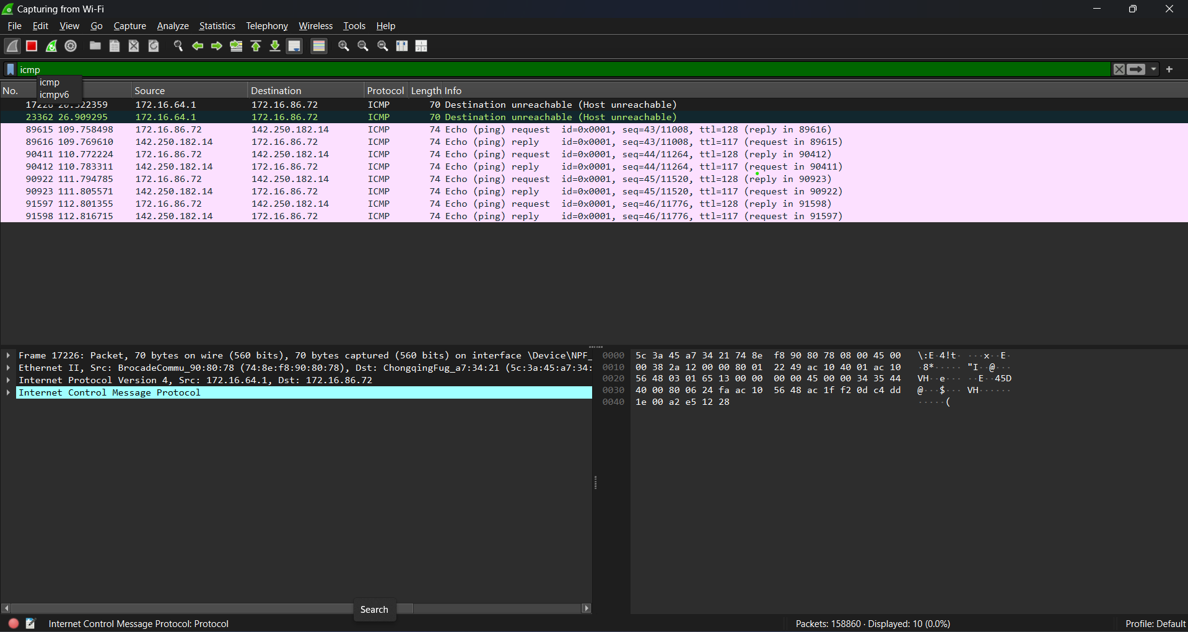
- To analyze TCP packets and observe the TCP three-way handshake

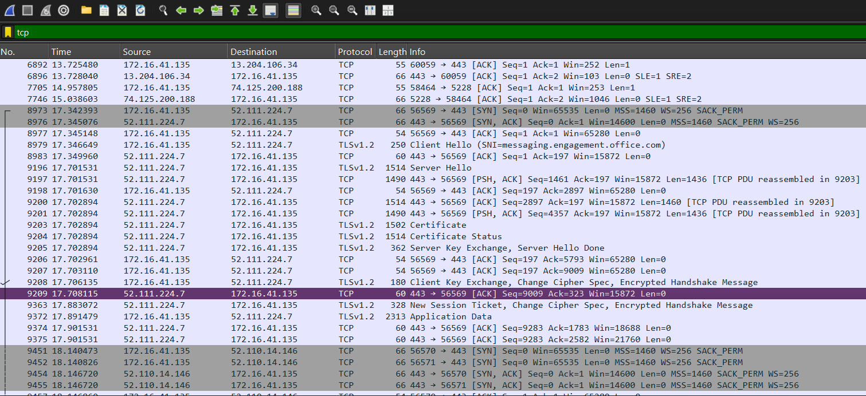

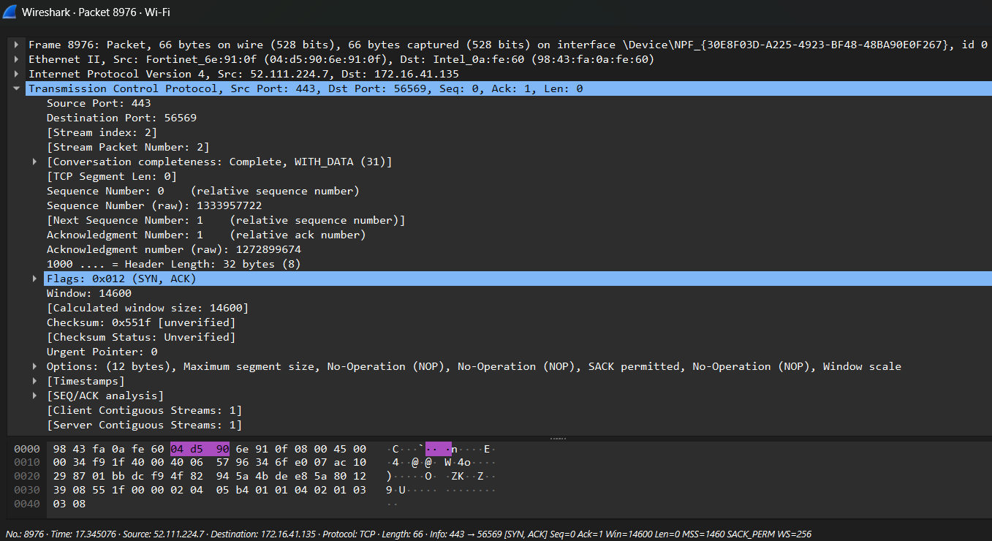

- To capture and analyze UDP packets

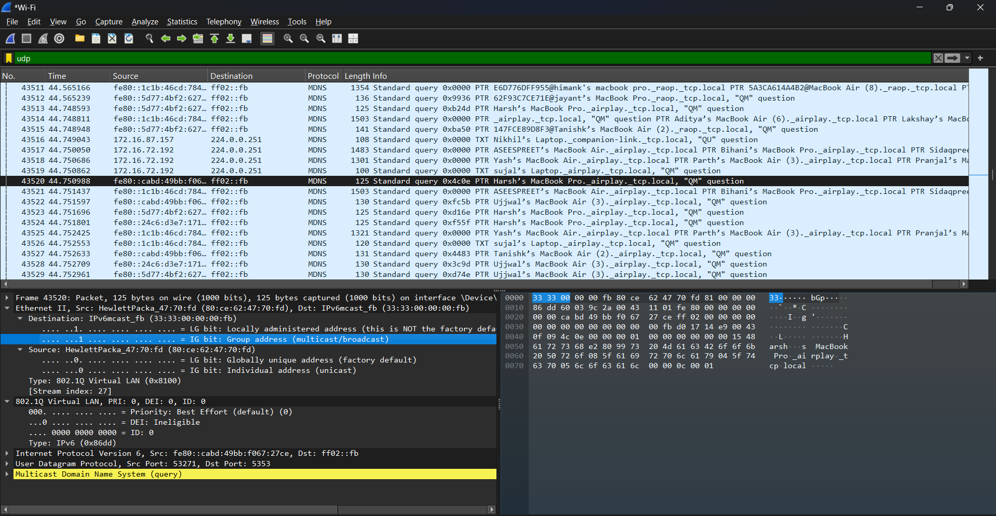

- To capture and analyze DNS query and response packets

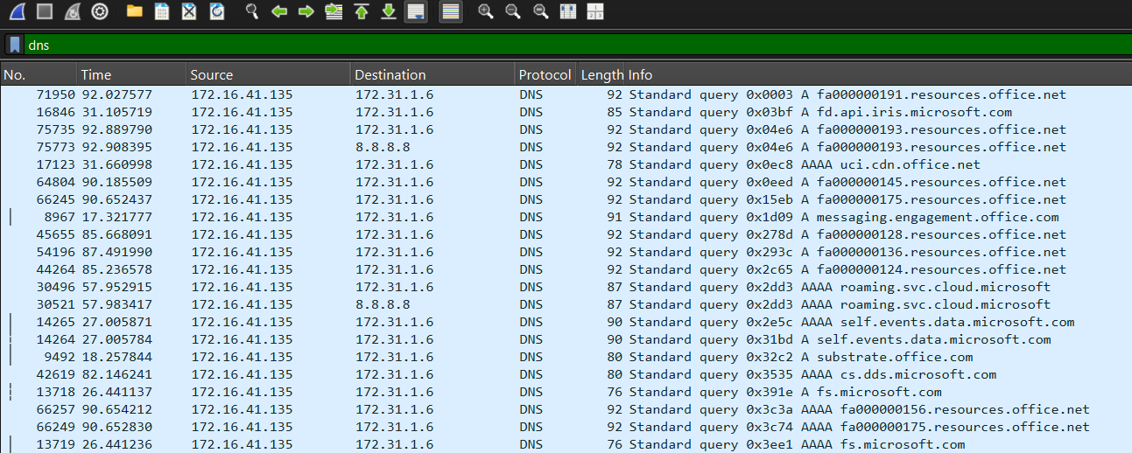

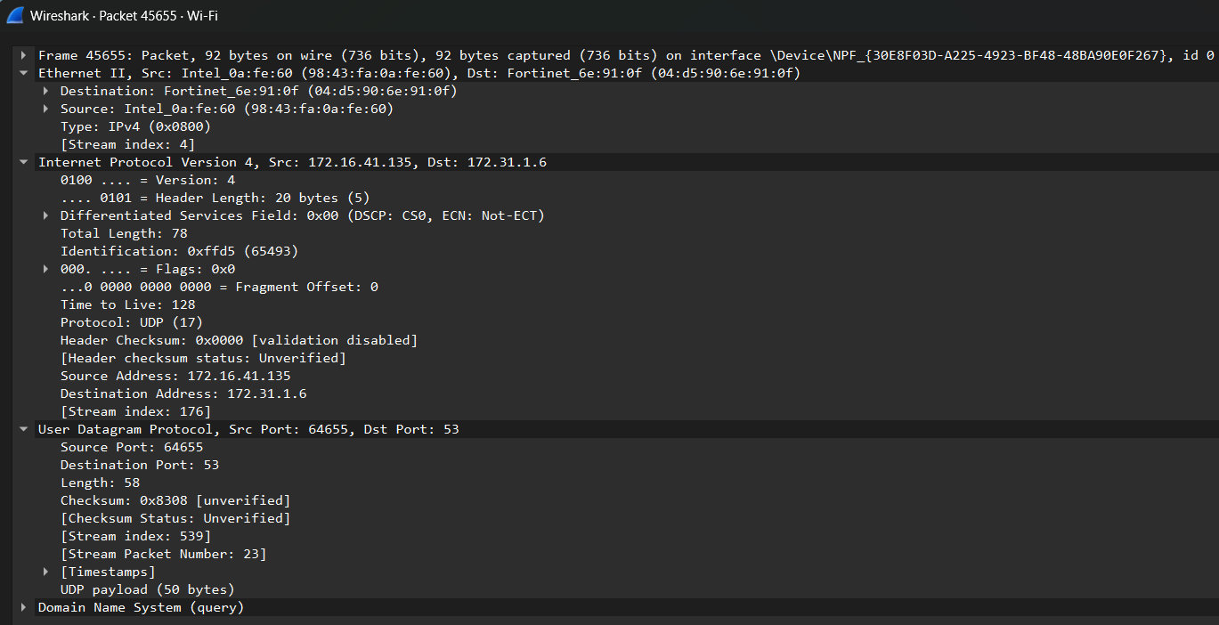

- To capture and analyze HTTP packets

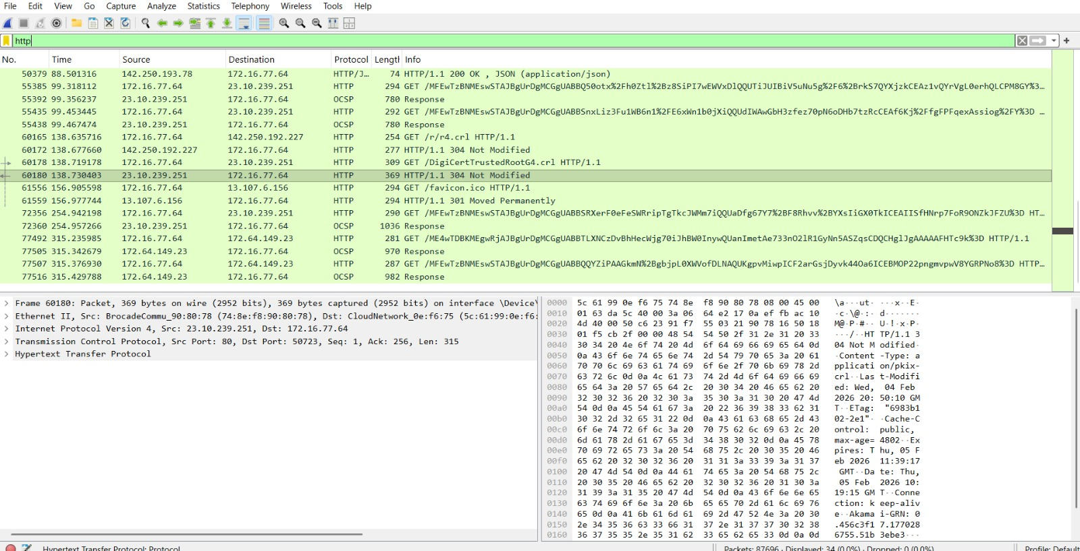

- To analyze ARP request and reply packets

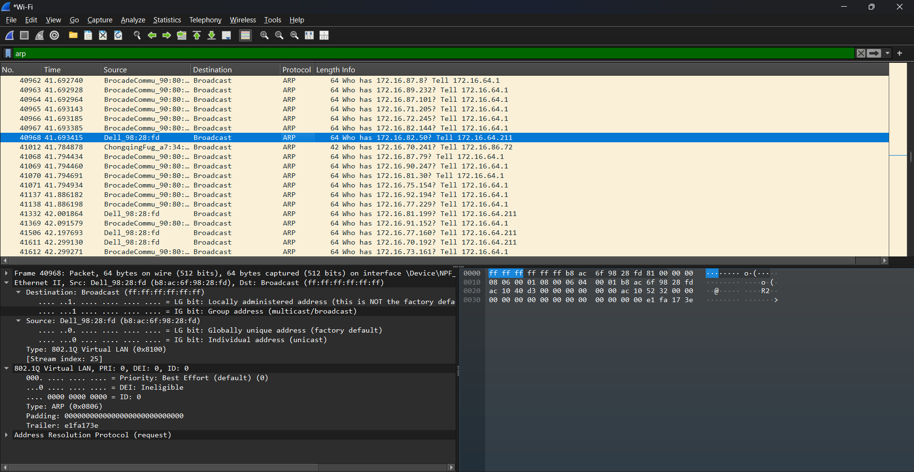

- To identify source and destination MAC and IP addresses in captured packets.

